**Assignment Advance Programming Lab 5**

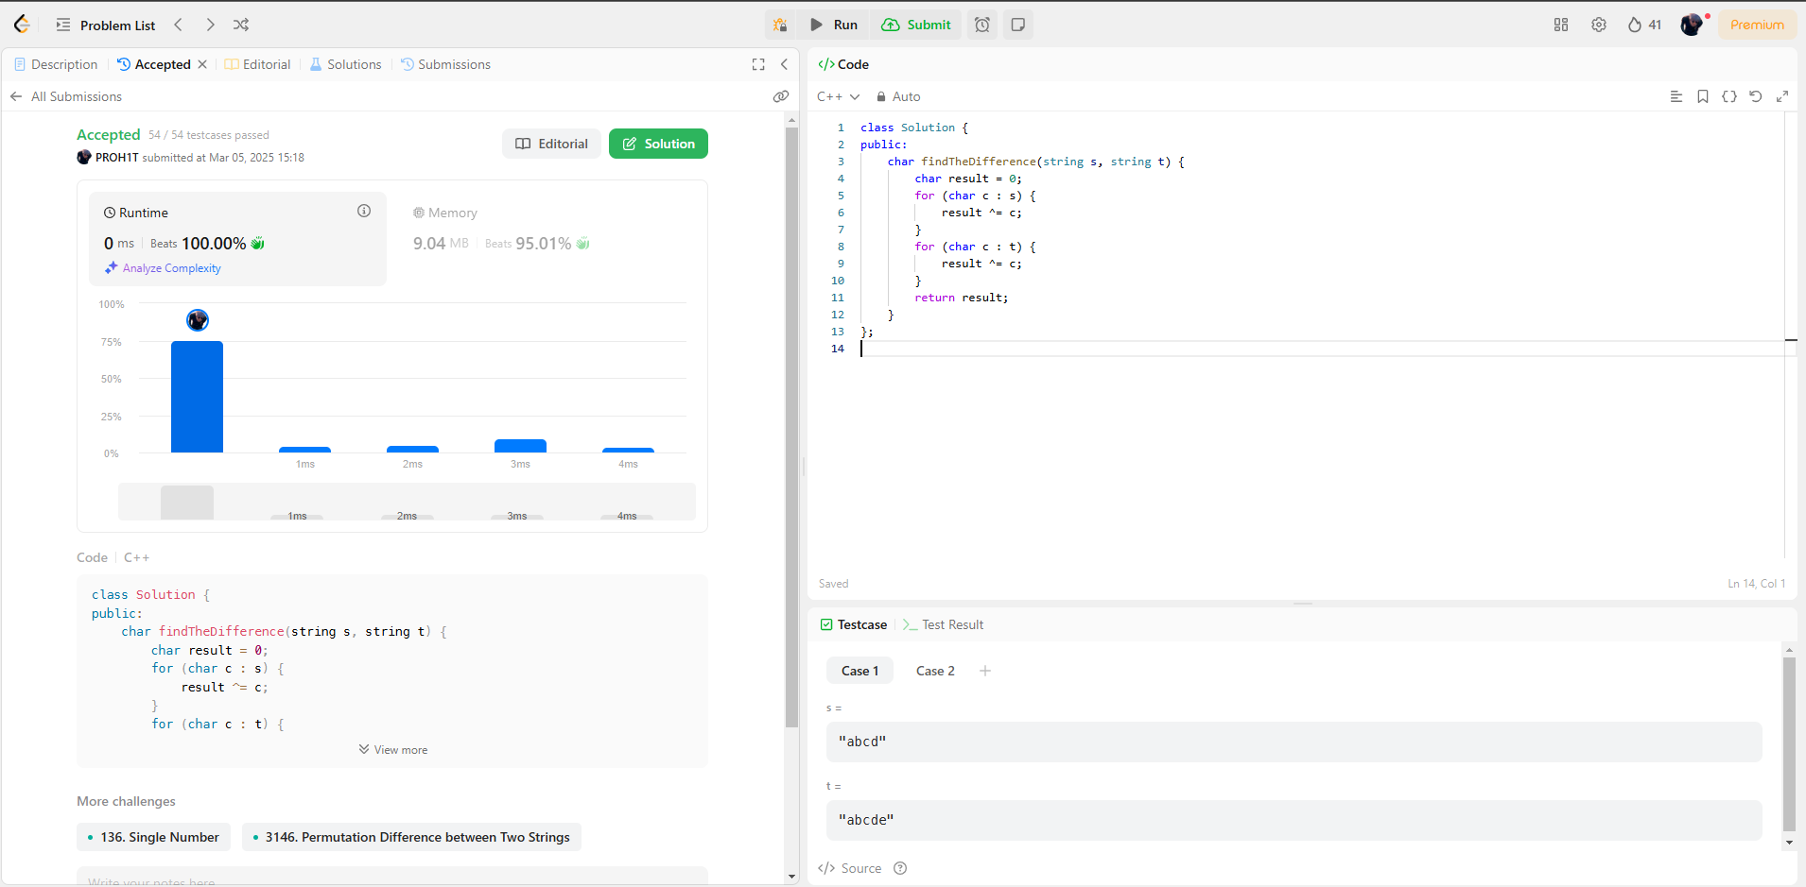[**389. Find the Difference**](https://leetcode.com/problems/find-the-difference/)

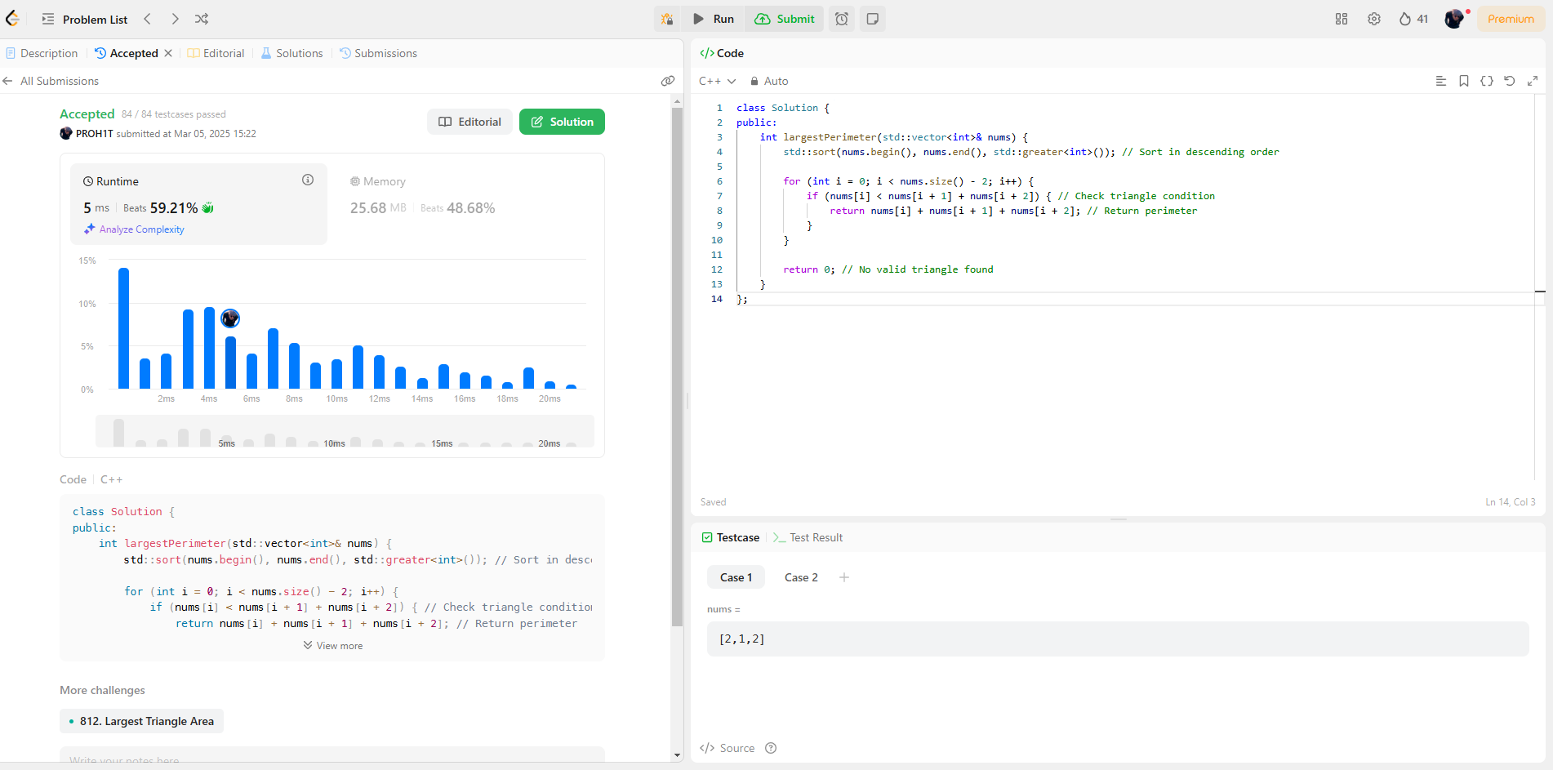[**976. Largest Perimeter Triangle**](https://leetcode.com/problems/largest-perimeter-triangle/)

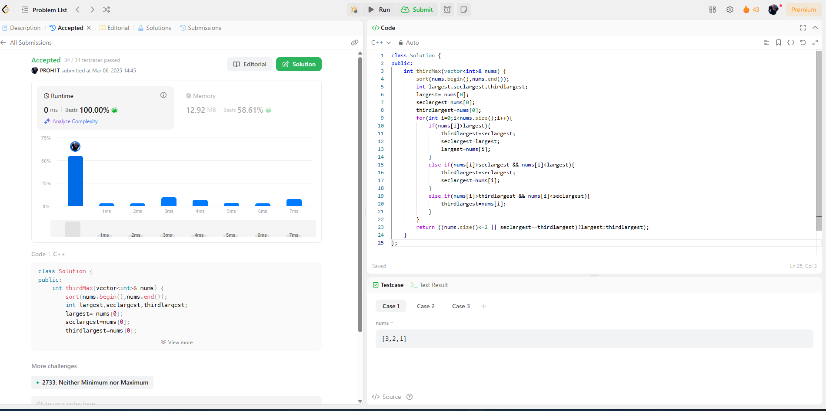**414.**[**Third Maximum Number**](https://leetcode.com/problems/third-maximum-number/description/)

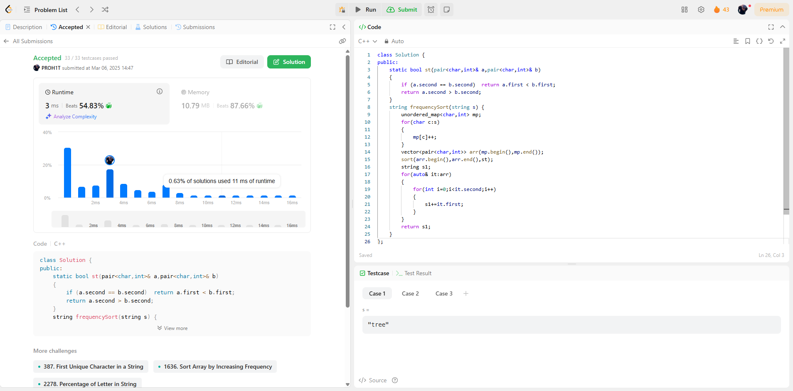**451.**[**Sort Characters By Frequency**](https://leetcode.com/problems/sort-characters-by-frequency/description/)

**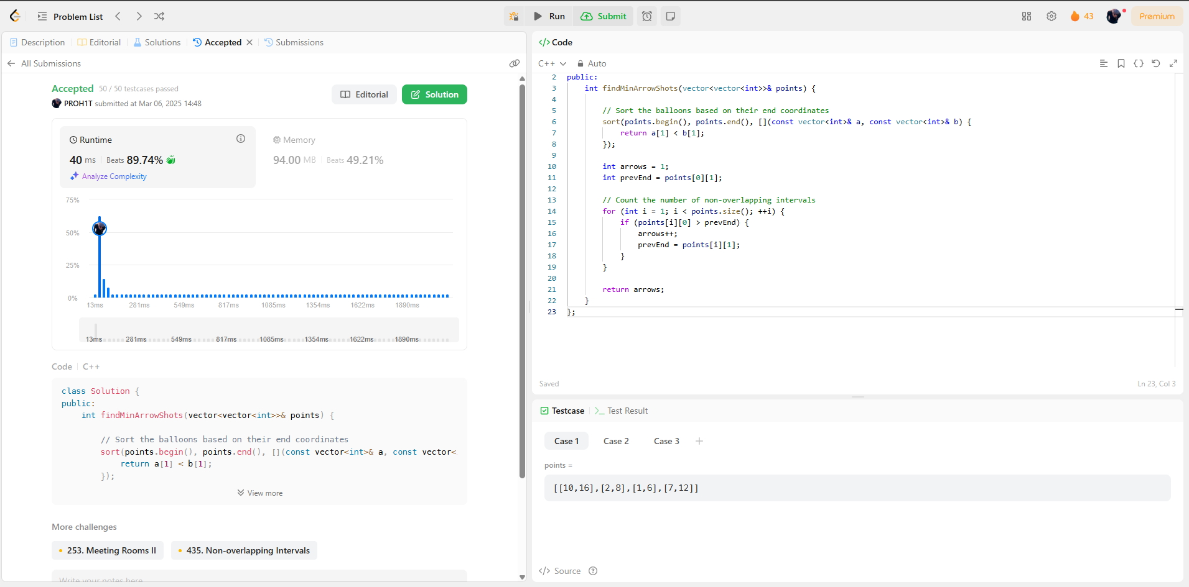  
452.**[**Minimum Number of Arrows to Burst Balloons**](https://leetcode.com/problems/minimum-number-of-arrows-to-burst-balloons/)

**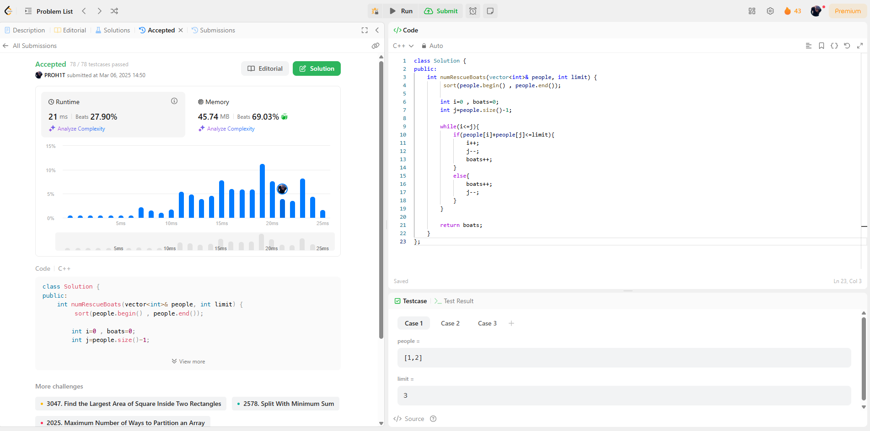  
881.**[**Boats to Save People**](https://leetcode.com/problems/boats-to-save-people/description/)

**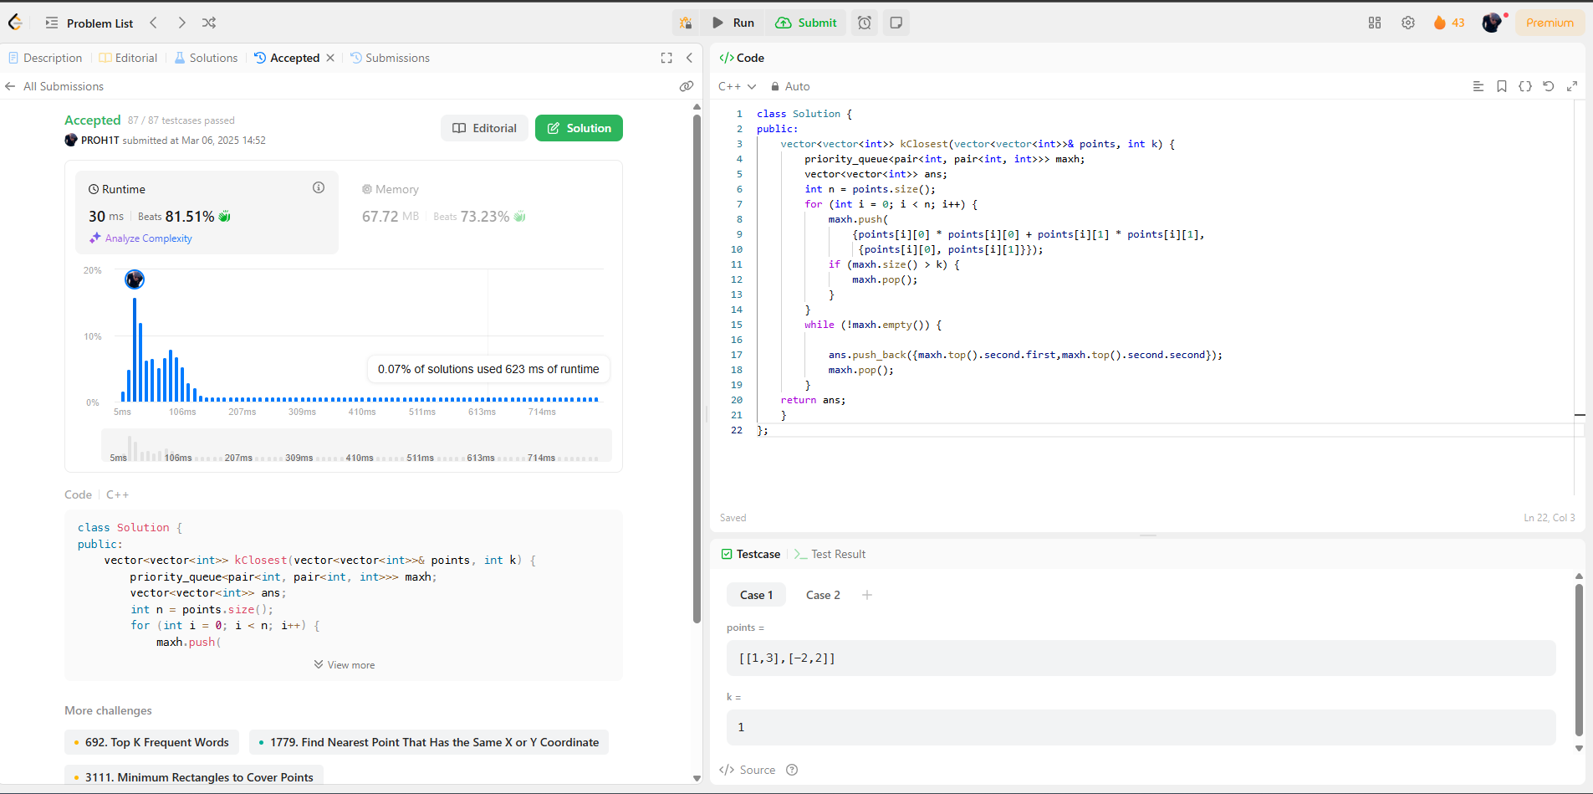  
973.**[**K Closest Points to Origin**](https://leetcode.com/problems/k-closest-points-to-origin/description/)

**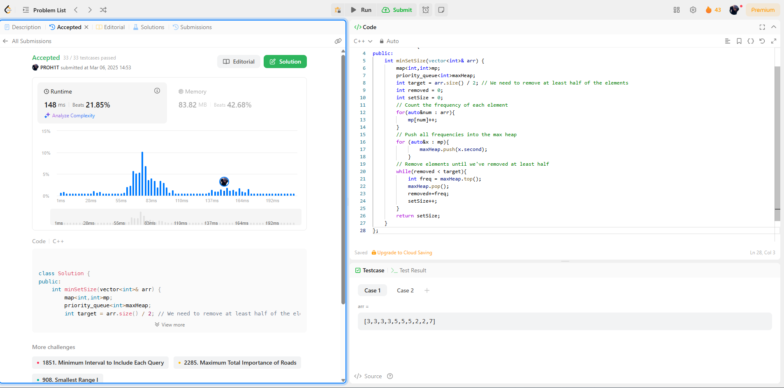  
1338.**[**Reduce Array Size to The Half**](https://leetcode.com/problems/reduce-array-size-to-the-half/description/)